Back to School Supplies
for our Supported Ministries

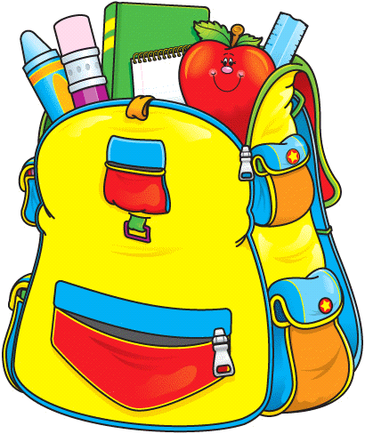
Anything your kids may need, these kid need! Including backpacks, pencils, paper, note books, scissors, pens, etc.
Drop off in Gathering Area August 4th an 5th

